Logistics and Supply Chain Management
  - Case Analysis of UPS

Executive Summary
Supply chain management is a critical aspect of any business that supports in the achievement of operational efficiency. The significance of an efficient supply chain is very high in the case of a company that is involved in logistics. In this study the case company considered is United Parcel Services (UPS) that operates within the third-party logistics industry thus indicating the importance of supply chain for its operational performance.
The study has been undertaken to analyse the logistics and supply chain related issues faced by the company. The background of the overall logistics and supply chain of UPS has been studied with the help of Porter’s value chain model. From the analysis it has been identified that though the company has been effective in enhancing its supply chain performance but yet it has been subjected to issues like supplier management, customer management and technological changes. To deal with these issues it has been recommended that the company should continue to invest in technologies, collaborate with suppliers across multiple layers of operations and expand into unknown territories. These recommendations would be implemented using the PDCA cycle.

Introduction Background
UPS is one of the most significant players in the industry of third-party logistics. The company is headquartered in Atlanta, United Sates and is operational since year 1907 (Bloomberg, 2018). Presently, the company provides employment to 238,830 people. The company today has an international presence in developed, developing and under-developed economies too.
The background of the overall logistics and supply chain management at UPS can be understood with the help of value chain model. Value chain is of the most integral aspect of the logistics and supply chain management is the value chain management. Value chain in simple words can be denoted as the nexus of relationships that are designed between the various components of a company in a manner that value is generated in terms of profits for the company and satisfaction for the consumers (Christopher, 2016). Within the value chain it is the amalgamation of primary and support activities that generate value. The value chain management has been designed by Michael Porter (Van Weele, 2010). The diagram below highlights the value chain against which the activities of an organisation are analysed:
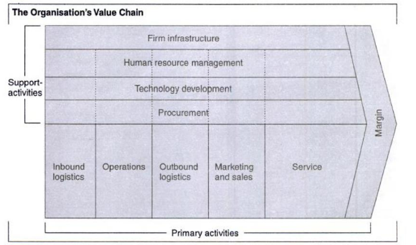
Figure 1 Value Chain Analysis
Source: (Jauch, et al., 2007)
Primary Activities
- Inbound Logistics: While sourcing the materials and other components, UPS takes utmost care ensuring that efficiencies are optimised. Also, the supply chain is designed in a manner that it supports free flow of information further ensuring that production costs are optimised and issues like excessive production and cost related to interruptions do not occur (UPS, 2014). The inventory at UPS is managed in a form that supports its international network as well as its operations.
- Operations: The operations at UPS are executed to ensure that product spoilage is minimised and global consumers are catered to in an effective and efficient manner. These operations in UPS are supported by Geographical information system (GIS) which is a mechanism to optimise supply chain (Perpina, et al., 2009). This GIS in UPS has been assisting the company in overcoming operational issues and thus ensure that it continues to be the leader within the logistics industries for delivery of products and services (Ball, 2017). With the help of this technology, UPS has been able to manage its flow of work by determining the pickup, sorting and delivery of parcels as soon as the order is being placed by the consumers.
- Outbound Logistics: The outbound logistics of the company are designed and developed in a manner that they serve both regional and global consumers. These outbound logistics resort to approaches to ensure that timely deliveries are being executed and overall order-to-delivery cycle is optimised. The logistics support swift flow of cash along with ensuring lessening of lead time.
- Marketing and Sales: the marketing strategy at UPS are designed to ensure that a consistent brand image is developed in the international markets. The marketing and sales of the company are done to both commercial and retails consumers. The packages are designed based on consumer requirements thus endowing them with customised services.
- Service: The primary intention of UPS is to provide for augmented consumer services thus enhancing their experience. The company has customer care representatives to resolve the queries and complaints of the clients who are accessible 24*7. It also provides for other support mechanisms to customers like shipping support, billing support, tracking support, packaging and supplies support and technology support to name a few (UPS, 2018).
Support Activities
- Firm Infrastructure: The organisational infrastructure has been developed on advanced technology that supports its global operations. UPS continues to pursue investments to strengthen its infrastructure as it recently invested approximately 163.24 million GBP in England to add facilities to supports its packing, sorting and delivery activities (Mandel, 2018).
- Human Resources Management: The company has an employee base of approximately 454,000 people who work round the clock for supporting organisational growth and thereby assisting in achievement of its vision (UPS, 2017). Regular training and development programs are being executed to ensure that employees and the organisation mutually develop.
- Technology Development: The technology adopted by UPS is advanced and supports its overall functioning. Some of the primary technologies as adopted by UPS are ORION which is an in-house navigation mechanism, Delivery Information Acquisition Device (DIAD) and UPS My Choice (Lopez, 2018; Baker, et al., 2008). The company has approximately 4800 employees who solely work in technology and related activities.
- Procurement: The procurement activities at UPS are being managed by a dedicated team that is UPS's Global Procurement team (UPS, 2018). It manages the international and national activities of the company. The primary activities of the team comprise of sourcing of materials, managing relationship with suppliers and choosing the right suppliers.

Analysis
For exploring the issues faced by UPS in management of its logistics and supply chain it is first important to identify the various aspects related to the chain. Some of the most significant aspects of the supply chain management are customer management, supplier relationship, collaboration, operations excellence, integrative technologies and channel alignment (Ross, 2011). The same has been depicted in figure below:
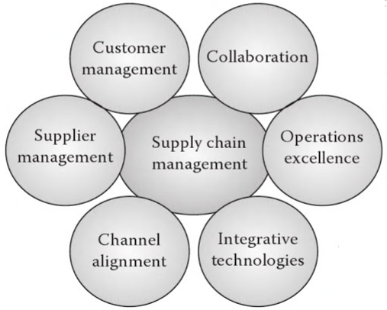
Figure 2 Aspects of Supply Chain Management
Source: (Ross, 2011)
Customer Management: Generating customer value is the ultimate vision of any company. Within contemporary business environment, management of customers is one of the most intricate spheres that a company needs to be manage cautiously and consciously (Russell & Taylor-Iii, 2008). With enhanced customer value a company is in a position to retain the consumers for a longer period of time thus generating revenues from them in a sustainable manner. For management of its customers and thus generate value for them, UPS uses the Zenkraft technology (UPS, 2018). With the help of this technology that endows consumer with requisite information in terms of process shipments, labels creation as well as track the position of their packages. Some of the primary features of this technology, ae creating labels in a single click thus supporting UPS to process orders swiftly and in a convenient manner. It provides right information to its customers regarding the exact delivery schedules of the products ordered using a Real-Time shipment tracking mechanism (Baker, et al., 2008). For further enhancing the supply chain efficiency through customer management, a series of measures have been executed through cost reduction (UPS , 2017). UPS has controlled cost related to order administration, total service and customer service. UPS is continually striving to achieve higher quality standards and enhance its market share.
Supplier Management: Another significant aspect of the logistics and supply chain management in the case of UPS is supplier management. Supplier management primarily refers to the various avenues from which a company sources its materials and the kind of relationship it maintains with them (Christopher, 2016). Supplier management is an intricate aspect of the supply chain primarily because it sets the overall supply chain into action. The effectiveness of sourcing strategy determines the overall efficiency of the supply chain. In UPS supplier management is governed by the principles of just-in-time (JIT). JIT is a system of management within the supply chain that ensures timely movement of products and services from suppliers to ultimate consumers thereby ensuring that inventories are not created and free flow is supported (Mackelprang & Nair, 2010). JIT in UPS has endowed the company with multiple benefits like process optimisation, effective flow of information, effective supplier management, meeting targets in time basis and ultimately resulting in organisational success (UPS, 2005).
A clear and transparent negotiation with the suppliers on terms like sourcing, pricing, liability, indemnification, payments, withdrawal and/or termination of services, warranty, intellectual property (IP), performance and deliveries are clearly specified within the supplier contract which assists the company in supplier management (UPS, 2015).
However, with increasing volume of operations at UPS the company is experiencing issues in supplier management. It is evident from the fact that a UPS the costs of revenues increased which put a pressure on supplier growth (CSIMarket, Inc., 2018). Owing to this pressure the supplier revenue growth experienced a decline as depicted in figure below:
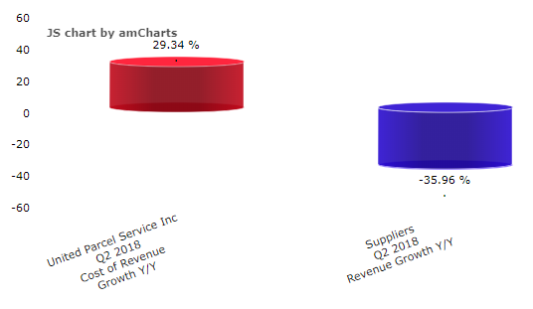
Figure 3 UPS Costs vs Sales of Suppliers Growth
Source: (CSIMarket, Inc., 2018)
Channel Alignment: Channel alignment is about the relationship within the supply chain between the supplier nodes and delivery nodes as established by an organisation thus bridging the gap between demand and supply (Oliva & Watson, 2011). Channel alignment in the case of UPS is complicated owing to multiple factors like scale of operations of the company, global networking and an array of suppliers and consumers (Hong Kong Trade Development Council, 2018). Also, with increasing technological changes, UPS is subjected to even complicated environment. In order to ensure channels within the company involved in its supply chain are appropriately managed the company operates through multiple hub designed across the world to cater to its global operations. For example, in the year 2002, UPS set-up a hub in Philippines, Asia to alignment of its operations in Asian-Pacific region and thus ensuring its smooth functioning. However, the company presently plans to shift this hub from Philippines to China to ensure that it is able to enhance its operational efficiency and realise cost efficiencies (Singapore Business Review, 2018)
Interactive Technologies: This mainly implies the various enabling technologies that are used by an organisation to ensure that the supply chain functions effectively and efficiently. In the modern-day business environment where internet has emerged one of the most significant aspects for dealing with globalised operations of a company, it is important for companies to have interactive technologies to support the supply chain (Varadarajan, et al., 2010). In the case of UPS also, as the company has global operations and networking, its supply chain is supported by a series of enabling technologies. The adoption of technology in UPS is guided by the principle of sustainability and is a procedural approach as depicted in figure below:

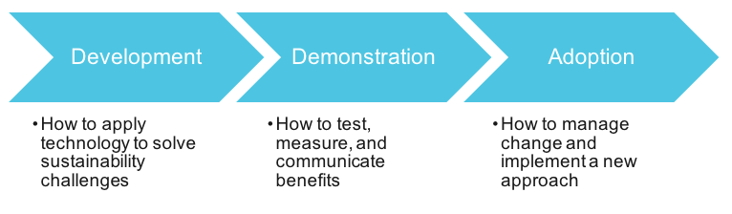
Figure 4 Delivering on Sustainability Solutions: From Idea to Action
Source: (Business for Social Responsibility, 2016)

As a matter of fact, UPS has been the pioneer in adopting these enabling technologies. For example, when most of the companies are still adopting to DIAD, UPS has already started using DIAD IV since year 1991 to augment its efficiencies in making deliveries to consumers (Hong Kong Trade Development Council, 2018). Other enabling technologies adopted by the company are Flex Global View and Global Positioning Satellite (GPS) technology to name a few. UPS continually updates these technologies thus providing seamless movement across its supply chain without compromising on its effectiveness and efficiency.
Recently, UPS has resorted to innovative technologies to enhance the overall performance of differing aspects of it supply chain. For example, Peak Volume Alignment Tool (PVAT) has been adopted to manage demand and integrate with its capacity management (UPS, 2018). Further, Network Planning Tools (NPT) have also been embarked upon to ensure that the vehicles movement is smooth and tailbacks are being avoided thereby making time deliveries (UPS, 2018). Harmonized Enterprise Analytics Tool (HEAT) is used to ensure that the various hubs of UPS operate in an effective manner without any interruptions and in a coordinated manner (UPS, 2018). Orion is another significant technology that is adopted by UPS to ensure route is optimised and the company is able to generate benefits at three levels namely, economic, social and environmental (Konrad, 2013).
Operational Excellence: Operational excellence implies to a situation where the companies have enhanced supply chain efficiencies indicating a high-performance scenario with cost that are optimal (Ross, 2011). Operational excellence within the supply chain is achieved when the supply chain is trustworthy and considered to be reliable by the stakeholders of the company. Also, the abilities of the supply chain to manage risks and its overall competency determines the level of excellence. UPS has a supply chain with higher operational excellence. It is evident from the fact that the company continues to add new technologies and overhaul existing approaches to meet the changing environmental demands (UPS, 2018). It has also been updating its hubs into high performing ones along with adding new capacities to it (UPS, 2018). The business portfolio of the company is diversified to ensure the risks are shared across the supply chain. However, the supply chain of UPS is not resilient to manage risks which is evident from the fact that the company has been financially affected with one of its major clients that is Amazon minimising transactions with UPS (Chandrasekhar, 2016). Amazon is setting up its own delivery systems owing to which UPS is losing upon its competitive edge and thus needs to undergo changes to further enhance its operational excellence.
Collaboration: Collaboration within the supply chain is specified “as an activity pursued jointly by two or more entities to achieve a common objective. It can mean anything from exchanging raw data to the most basic means, to the periodic sharing of information through technology-based tools, to the structuring of real-time architectures capable of leveraging highly independent infrastructures in the pursuit of complex, tightly integrated functions ensuring planning, execution, and information synchronization” (Ross, 2011, p: 28). For achievement of supply chain efficiencies, UPS too has resorted to a series of collaboratiosn at differing levels. For example, for development of technologies like DIAD, UPS collabtated with Symbol Technologies (Hong Kong Trade Development Council, 2018). The company has also collaborated with IBM to avail multiple technological solutions for smooth functioning and sustaining its leadership position within the industry (Seybold, 1999; Krayer, 2017). These solutions are provided within the sphere of customer service, delivery systems, billing systems and internet shipping systems to name a few. The support from IBM has assisted the company to operate effectively as a e-business organisation.

Recommendations and Implementation Plan
From the above analysis it is clearly evident that UPS as an organisation has not only been a dominant player within the industry of third-party logistics but also has a supply chain and logistics management mechanism that is highly effective and efficient. However, with increasing competitive pressure and changing dynamism of business environmental factors it is important for the company to continually enhance its supply chain and logistics management approach thus continuing to lead the industry with its core competencies and capabilities. Based on the analysis and considering the business environmental factors a few recommendations are put forward to UPS.
Firstly, it is recommended that the company continue to invest in sustainable practices. These sustainable practices should be directed to environmental sustainability, economic sustainability as well as social sustainability. These sustainable practices might range from resorting to investments in research and development to further enhance fuel efficiency of its vehicles and use modern technologies that would minimise carbon footprint. Another approach that UPS can resort to is reverse logistics. This will also assist the company in promoting environmental as well as economic sustainability.
Secondly, it is recommended that given the scale of operations and facilities UPS has it can expand its business portfolio by penetrating into new markets and adding new products and services to its profile. UPS has been known for effective delivery of products but it can add provision of services to its customers too. This can be done by collaborating with service providers which act as a support system to both commercial and individual consumers. These services can range from making efforts for risk mitigation through provision of insurance services and inventory management services too.
Thirdly, it is recommended that as the company has been exposed to issues like supplier management it should adapt practices like collaboration with them at every stage of operations thus ensuring faster deliveries are being made to consumers and effective relationship with suppliers through active participation.
For implementation of these approaches a detailed planning would be undertaken. Each of the issue will be undertaken separately and systematic efforts will be designed to implement solutions. In brief a project management approach based on the principles of Plan-Do-Check-Act (PDCA) would be adopted (Sokovic, et al., 2010). The model has been depicted in figure below:
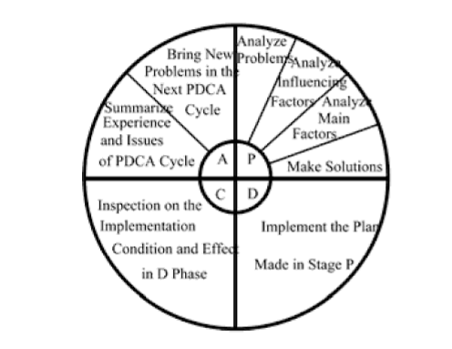
Figure 5 PDCA Cycle
Source: (Lin & Huang, 2011)
Under this approach, firstly the plans for appropriate mechanisms to be adopted for overcoming issues will be designed. These planning will be undertaken with the help of expert panel that would be developed specifically to deal with the specific issue in concern. Once the solutions to the problems are identified the most appropriate one would be chosen. The chosen solution will be developed and implemented on a small scale to test its viability. Based on sample implementation, the changes will be done in the check stage and finally the changes will be inculcated and the solution will be ultimately implemented across the organisation. The changes are aimed at improvement of holistic quality of services provided by UPS (Sokovic, et al., 2010).

